Before using the python code, you should download two libraries ‘request’ and ‘lxml’

I’ll show you the changes you need to do with the code.

First,change the headers.

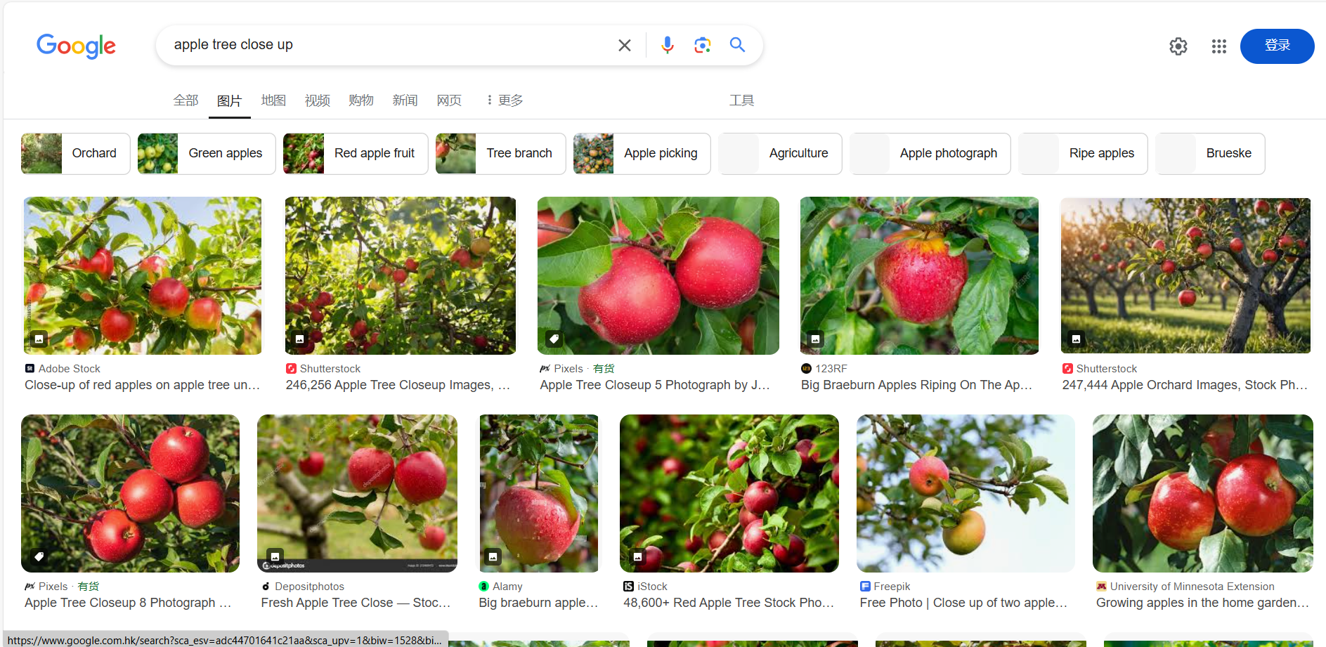

Right click on the page to check

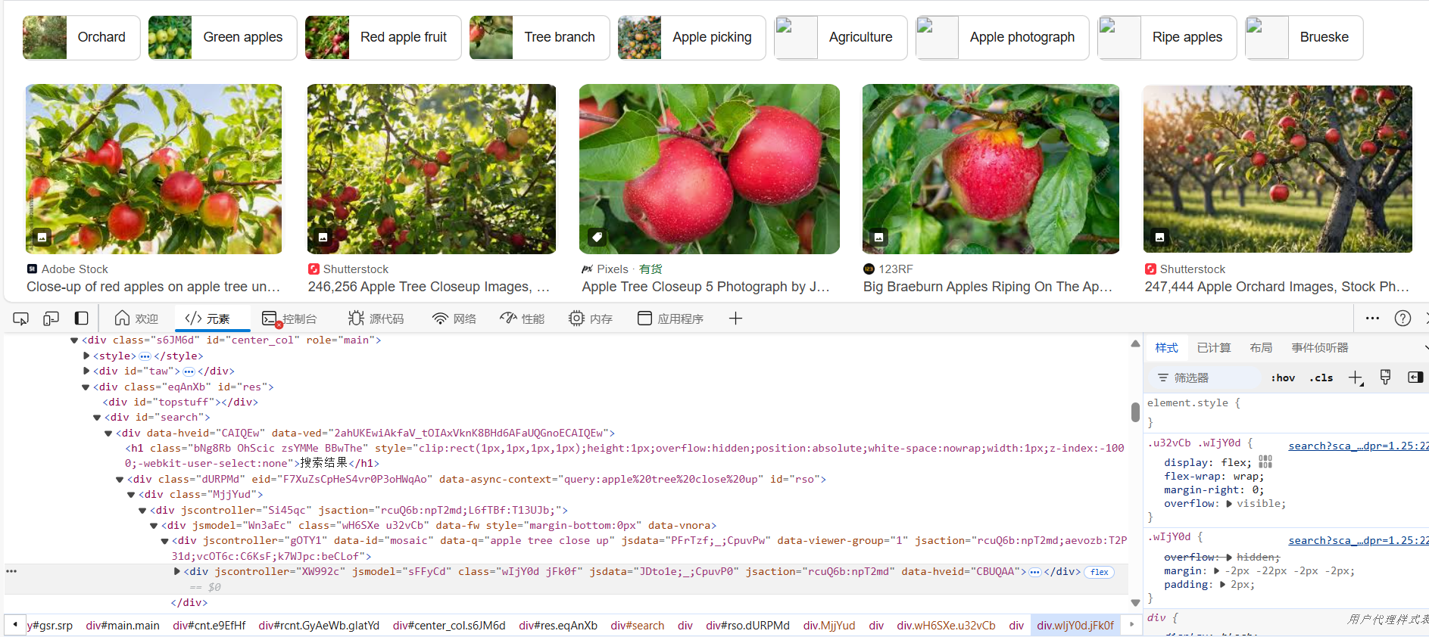

Then click network, refresh the page and select the first item

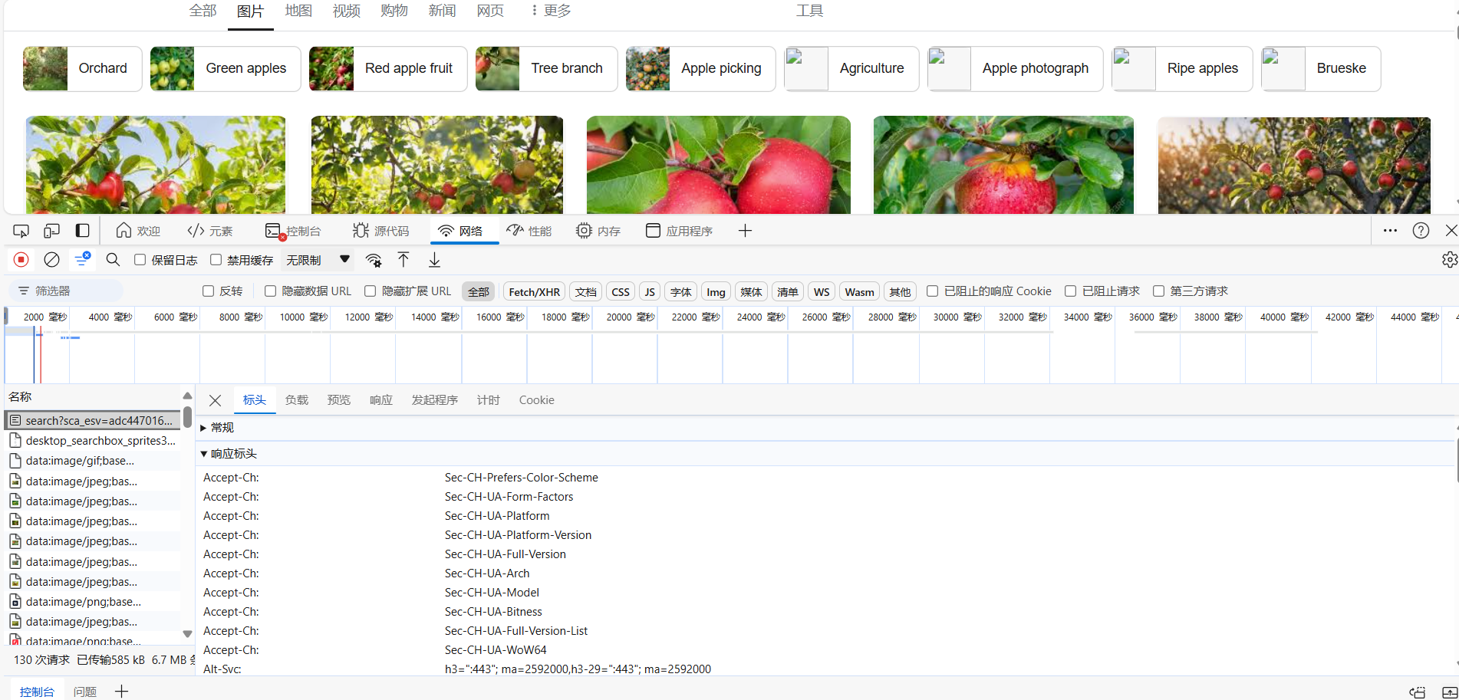

Scroll down the page to find the request header.

Change the User-Agent, Cookie, and Accept in the code to match what's on the page.

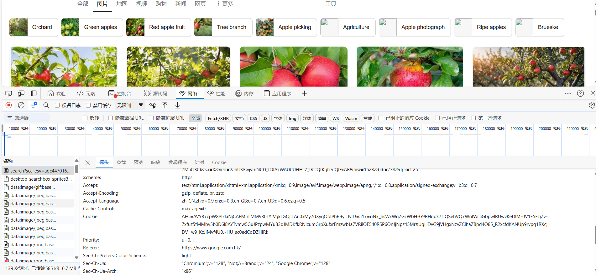

Second,change the url to the URL of the search page.

Third,change the xpath of images.(you need to learn xpath first)

Hover your mouse over the image and right-click to check,

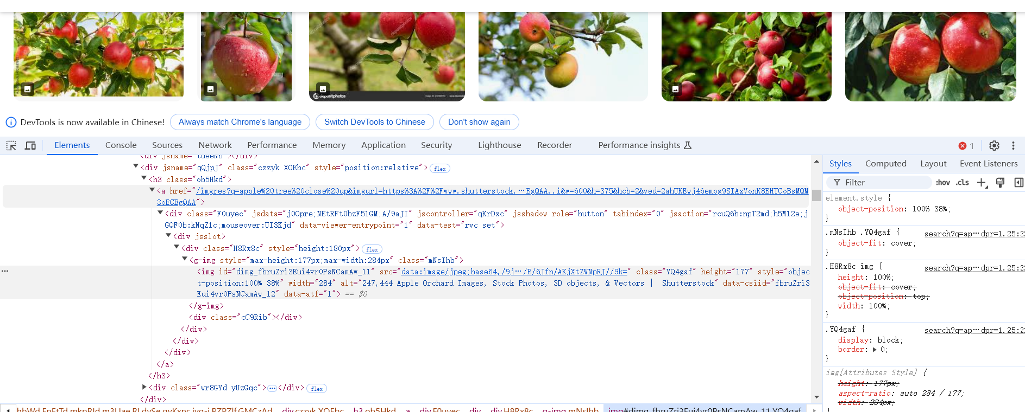

Write the xpath of the src of the image and replace it to the code.